Lab Taks-4

Question- 1

Draw the scenario of a traffic signal using function to represent each object

Graph Plot (Picture)-

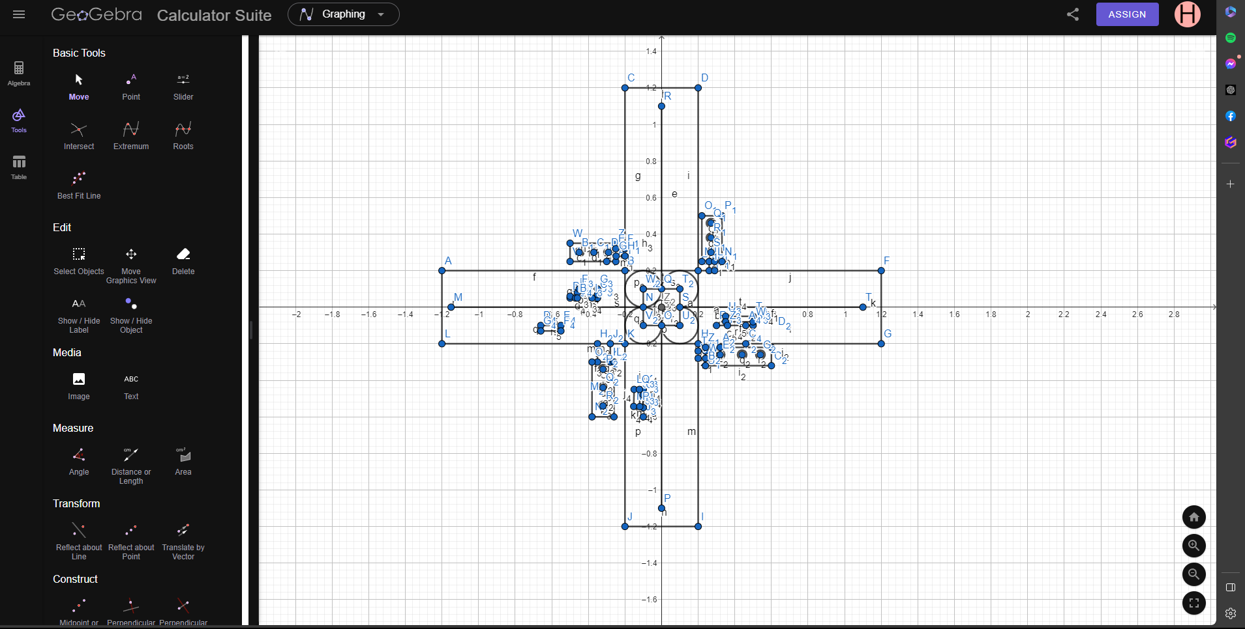
CODE:
#include <windows.h>
#include <GL/glut.h>
#include<math.h>
void traficlight()
{
glBegin(GL_POLYGON);

glColor3f(1.0f, 1.0f, 1.0f);
glVertex2f(-1.2, 0.2);
glVertex2f(-1.2, -0.2);
glVertex2f(-0.2, -0.2);
glVertex2f(-0.2, 0.2);

glEnd();

glBegin(GL_POLYGON);

glColor3f(1.0f, 1.0f, 1.0f);
glVertex2f(-0.2, 1.2);
glVertex2f(-0.2, 0.2);
glVertex2f(0.2, 0.2);
glVertex2f(0.2, 1.2);

glEnd();

glBegin(GL_POLYGON);

glColor3f(1.0f, 1.0f, 1.0f);
glVertex2f(1.2, 0.2);
glVertex2f(1.2, -0.2);
glVertex2f(0.2, -0.2);
glVertex2f(0.2, 0.2);

glEnd();

glBegin(GL_POLYGON);

glColor3f(1.0f, 1.0f, 1.0f);
glVertex2f(-0.2, -1.2);
glVertex2f(0.2, -1.2);
glVertex2f(0.2, -0.2);
glVertex2f(-0.2, -0.2);

glEnd();

glBegin(GL_POLYGON);

glColor3f(1.0f, 1.0f, 1.0f);
glVertex2f(-0.2, 0.2);
glVertex2f(-0.2, -0.2);
glVertex2f(0.2, -0.2);
glVertex2f(0.2, 0.2);

glEnd();

glEnable(GL_LINE_STIPPLE);
glColor3f(0.0f, 0.0f, 0.0f);
glLineStipple(5, 0x0C0F);
glBegin(GL_LINES);
glVertex2f(-1.15, 0.0);
glVertex2f(-0.1, 0.0);
glVertex2f(0, -1.1);
glVertex2f(0, -0.1);
glVertex2f(1.1, 0);
glVertex2f(0.1, 0.0);
glVertex2f(0.0, 1.1);
glVertex2f(0.0, 0.1);

glEnd();

glDisable(GL_LINE_STIPPLE);

glEnd();
glBegin(GL_POLYGON);

glColor3f(0.0f, 0.0f, 0.0f);
glVertex2f(-0.1, 0.1);
glVertex2f(-0.1, -0.1);
glVertex2f(0.1, -0.1);
glVertex2f(0.1, 0.1);

glEnd();
glBegin(GL_POLYGON);
float xOffa = -0.1f;
float yOffa = 0.1f;
for (int i = 0; i < 300; i++)
{

glColor3f(1.0f, 1.0f, 1.0f);
float pi = 3.1416;
float a = (i * 2 * pi) / 300;
float r = 0.1;
float x = r * cos(a) + xOffa;
float y = r * sin(a) + yOffa;
glVertex2f(x, y);

}

glEnd();

glBegin(GL_POLYGON);
float xOffa2 = 0.1f;
float yOffa2 = 0.1f;
for (int i = 0; i < 300; i++)
{

glColor3f(1.0f, 1.0f, 1.0f);
float pi = 3.1416;
float a = (i * 2 * pi) / 300;
float r = 0.1;
float x = r * cos(a) + xOffa2;
float y = r * sin(a) + yOffa2;
glVertex2f(x, y);

}

glEnd();
glBegin(GL_POLYGON);
float xOffa3 = 0.1f;
float yOffa3 = -0.1f;
for (int i = 0; i < 300; i++)
{

glColor3f(1.0f, 1.0f, 1.0f);
float pi = 3.1416;
float a = (i * 2 * pi) / 300;
float r = 0.1;
float x = r * cos(a) + xOffa3;
float y = r * sin(a) + yOffa3;
glVertex2f(x, y);

}

glEnd();
glBegin(GL_POLYGON);
float xOffa4 = -0.1f;
float yOffa4 = -0.1f;
for (int i = 0; i < 300; i++)
{

glColor3f(1.0f, 1.0f, 1.0f);
float pi = 3.1416;
float a = (i * 2 * pi) / 300;
float r = 0.1;
float x = r * cos(a) + xOffa4;
float y = r * sin(a) + yOffa4;
glVertex2f(x, y);

}

glEnd();

glBegin(GL_POLYGON);
float xOffa5 = 0.0f;
float yOffa5 = 0.f;
for (int i = 0; i < 300; i++)
{

glColor3f(1.0f, 1.0f, 1.0f);
float pi = 3.1416;
float a = (i * 2 * pi) / 300;
float r = 0.04;
float x = r * cos(a) + xOffa5;
float y = r * sin(a) + yOffa5;
glVertex2f(x, y);

}

glEnd();
glBegin(GL_POLYGON);

glColor3f(1.0f, 1.0f, 1.0f);
glVertex2f(-0.38, -0.3);
glVertex2f(-0.26, -0.3);
glVertex2f(-0.26, -0.6);
glVertex2f(-0.38, -0.6);

glEnd();

glBegin(GL_POLYGON);

glColor3f(1.0f, 1.0f, 1.0f);
glVertex2f(-0.35, -0.2005);
glVertex2f(-0.28, -0.2005);
glVertex2f(-0.28, -0.3);
glVertex2f(-0.35, -0.3);

glEnd();

glBegin(GL_POLYGON);

glColor3f(1.0f, 1.0f, 1.0f);
glVertex2f(-0.5, 0.35);
glVertex2f(-0.5, 0.25);
glVertex2f(-0.25, 0.25);
glVertex2f(-0.25, 0.35);

glEnd();

glBegin(GL_POLYGON);

glColor3f(1.0f, 1.0f, 1.0f);
glVertex2f(-0.2, 0.28);
glVertex2f(-0.2481812657682, 0.2792777718654);
glVertex2f(-0.25, 0.32);
glVertex2f(-0.2, 0.32);

glEnd();
glBegin(GL_POLYGON);

glColor3f(1.0f, 1.0f, 1.0f);
glVertex2f(0.22, 0.5);
glVertex2f(0.22, 0.25);
glVertex2f(0.33, 0.25);
glVertex2f(0.33, 0.5);

glEnd();
glBegin(GL_POLYGON);

glColor3f(1.0f, 1.0f, 1.0f);
glVertex2f(0.26, 0.2);
glVertex2f(0.29, 0.2);
glVertex2f(0.28994796877, 0.2501393887935);
glVertex2f(0.26, 0.25);

glEnd();

glBegin(GL_POLYGON);

glColor3f(1.0f, 1.0f, 1.0f);
glVertex2f(0.24, -0.22);
glVertex2f(0.24, -0.32);
glVertex2f(0.6, -0.32);
glVertex2f(0.6, -0.22);

glEnd();
glBegin(GL_POLYGON);

glColor3f(1.0f, 1.0f, 1.0f);
glVertex2f(0.2, -0.24);
glVertex2f(0.2, -0.28);
glVertex2f(0.24, -0.28);
glVertex2f(0.24, -0.24);

glEnd();
glBegin(GL_POLYGON);
float xOffa1 = 0.32f;
float yOffa1 = -0.26f;
for (int i = 0; i < 300; i++)
{

glColor3f(1.0f, 0.0f, 0.0f);
float pi = 3.1416;
float a = (i * 2 * pi) / 300;
float r = 0.025;
float x = r * cos(a) + xOffa1;
float y = r * sin(a) + yOffa1;
glVertex2f(x, y);

}
glEnd();
glBegin(GL_POLYGON);
float xOffa11 = 0.44f;
float yOffa11 = -0.26f;
for (int i = 0; i < 300; i++)
{

glColor3f(0.0f, 1.0f, 0.0f);
float pi = 3.1416;
float a = (i * 2 * pi) / 300;
float r = 0.025;
float x = r * cos(a) + xOffa11;
float y = r * sin(a) + yOffa11;
glVertex2f(x, y);

}
glEnd();
glBegin(GL_POLYGON);
float xOffa1q1 = 0.54f;
float yOffa1q1 = -0.26f;
for (int i = 0; i < 300; i++)
{

glColor3f(1.0f, 1.0f, 0.0f); // Set color to yellow

float pi = 3.1416;
float a = (i * 2 * pi) / 300;
float r = 0.025;
float x = r * cos(a) + xOffa1q1;
float y = r * sin(a) + yOffa1q1;
glVertex2f(x, y);

}
glEnd();

//2
glBegin(GL_POLYGON);
float xOffa12 = 0.27f;
float yOffa12 = 0.3f;
for (int i = 0; i < 300; i++)
{

glColor3f(1.0f, 0.0f, 0.0f);
float pi = 3.1416;
float a = (i * 2 * pi) / 300;
float r = 0.025;
float x = r * cos(a) + xOffa12;
float y = r * sin(a) + yOffa12;
glVertex2f(x, y);

}
glEnd();
glBegin(GL_POLYGON);
float xOffa113 = 0.27f;
float yOffa113 = 0.38f;
for (int i = 0; i < 300; i++)
{

glColor3f(0.0f, 1.0f, 0.0f);
float pi = 3.1416;
float a = (i * 2 * pi) / 300;
float r = 0.025;
float x = r * cos(a) + xOffa113;
float y = r * sin(a) + yOffa113;
glVertex2f(x, y);

}
glEnd();
glBegin(GL_POLYGON);
float xOffa1q12 = 0.27f;
float yOffa1q12 = 0.46f;
for (int i = 0; i < 300; i++)
{

glColor3f(1.0f, 1.0f, 0.0f); // Set color to yellow

float pi = 3.1416;
float a = (i * 2 * pi) / 300;
float r = 0.025;
float x = r * cos(a) + xOffa1q12;
float y = r * sin(a) + yOffa1q12;
glVertex2f(x, y);

}
glEnd();
//3
glBegin(GL_POLYGON);
float xOffa221 = -0.45f;
float yOffa221 = 0.3f;
for (int i = 0; i < 300; i++)
{

glColor3f(1.0f, 0.0f, 0.0f);
float pi = 3.1416;
float a = (i * 2 * pi) / 300;
float r = 0.025;
float x = r * cos(a) + xOffa221;
float y = r * sin(a) + yOffa221;
glVertex2f(x, y);

}
glEnd();
glBegin(GL_POLYGON);
float xOffa1331 = -0.37f;
float yOffa1331 = 0.3f;
for (int i = 0; i < 300; i++)
{

glColor3f(0.0f, 1.0f, 0.0f);
float pi = 3.1416;
float a = (i * 2 * pi) / 300;
float r = 0.025;
float x = r * cos(a) + xOffa1331;
float y = r * sin(a) + yOffa1331;
glVertex2f(x, y);

}
glEnd();
glBegin(GL_POLYGON);
float xOffa1wq1 = -0.29f;
float yOffa1wq1 = 0.3f;
for (int i = 0; i < 300; i++)
{

glColor3f(1.0f, 1.0f, 0.0f); // Set color to yellow

float pi = 3.1416;
float a = (i * 2 * pi) / 300;
float r = 0.025;
float x = r * cos(a) + xOffa1wq1;
float y = r * sin(a) + yOffa1wq1;
glVertex2f(x, y);

}
glEnd();

//4
glBegin(GL_POLYGON);
float xOffa312 = -0.32f;
float yOffa312 = -0.34f;
for (int i = 0; i < 300; i++)
{

glColor3f(1.0f, 0.0f, 0.0f);
float pi = 3.1416;
float a = (i * 2 * pi) / 300;
float r = 0.025;
float x = r * cos(a) + xOffa312;
float y = r * sin(a) + yOffa312;
glVertex2f(x, y);

}
glEnd();
glBegin(GL_POLYGON);
float xOffa1132 = -0.32f;
float yOffa1132 = -0.44f;
for (int i = 0; i < 300; i++)
{

glColor3f(0.0f, 1.0f, 0.0f);
float pi = 3.1416;
float a = (i * 2 * pi) / 300;
float r = 0.025;
float x = r * cos(a) + xOffa1132;
float y = r * sin(a) + yOffa1132;
glVertex2f(x, y);

}
glEnd();
glBegin(GL_POLYGON);
float xOffa1q122 = -0.32f;
float yOffa1q122 = -0.54f;
for (int i = 0; i < 300; i++)
{

glColor3f(1.0f, 1.0f, 0.0f); // Set color to yellow

float pi = 3.1416;
float a = (i * 2 * pi) / 300;
float r = 0.025;
float x = r * cos(a) + xOffa1q122;
float y = r * sin(a) + yOffa1q122;
glVertex2f(x, y);

}
glEnd();
glFlush();
}

void cars()
{
glBegin(GL_POLYGON);

glColor3f(0.0f, 0.0f, 0.0f);
glVertex2f(-0.35, 0.05);
glVertex2f(-0.5, 0.05);
glVertex2f(-0.5, 0.06);
glVertex2f(-0.46, 0.08);
glVertex2f(-0.45, 0.1);
glVertex2f(-0.35, 0.1);

glEnd();
glBegin(GL_POLYGON);
float xOffa5 = -0.47f;
float yOffa5 = 0.05f;
for (int i = 0; i < 300; i++)
{

glColor3f(1.0f, 0.0f, 0.0f);
float pi = 3.1416;
float a = (i * 2 * pi) / 300;
float r = 0.01;
float x = r * cos(a) + xOffa5;
float y = r * sin(a) + yOffa5;
glVertex2f(x, y);

}

glEnd();

//2nd
glBegin(GL_POLYGON);

glEnd();
glBegin(GL_POLYGON);
float xOffa1 = -0.38f;
float yOffa1 = 0.05f;
for (int i = 0; i < 300; i++)
{

glColor3f(1.0f, 0.0f, 0.0f);
float pi = 3.1416;
float a = (i * 2 * pi) / 300;
float r = 0.01;
float x = r * cos(a) + xOffa1;
float y = r * sin(a) + yOffa1;
glVertex2f(x, y);

}

glEnd();
glBegin(GL_POLYGON);

glColor3f(0.0f, 0.0f, 0.0f);
glVertex2f(0.3, -0.1);
glVertex2f(0.35, -0.05);
glVertex2f(0.5, -0.05);
glVertex2f(0.5, -0.1);

glEnd();
glBegin(GL_POLYGON);
float xOffa2221 = 0.36f;
float yOffa2221 = -0.1f;
for (int i = 0; i < 300; i++)
{

glColor3f(1.0f, 0.0f, 0.0f);
float pi = 3.1416;
float a = (i * 2 * pi) / 300;
float r = 0.01;
float x = r * cos(a) + xOffa2221;
float y = r * sin(a) + yOffa2221;
glVertex2f(x, y);

}

glEnd();
glBegin(GL_POLYGON);
float xOffa22212 = 0.46f;
float yOffa22212 = -0.1f;
for (int i = 0; i < 300; i++)
{

glColor3f(1.0f, 0.0f, 0.0f);
float pi = 3.1416;
float a = (i * 2 * pi) / 300;
float r = 0.01;
float x = r * cos(a) + xOffa22212;
float y = r * sin(a) + yOffa22212;
glVertex2f(x, y);

}

glEnd();
glFlush();

}
void display() {

glClearColor(0.0f, 0.8f, 0.0f, 1.0f);
glClear(GL_COLOR_BUFFER_BIT);
glLineWidth(5);
traficlight();
cars();
}

int main(int argc, char** argv) {

glutInit(&argc, argv);

glutCreateWindow("OpenGL Setup");

glutInitWindowSize(5000, 4000);

glutDisplayFunc(display);
glutMainLoop();

return 0;

}

Output Screenshot (Full Screen)-

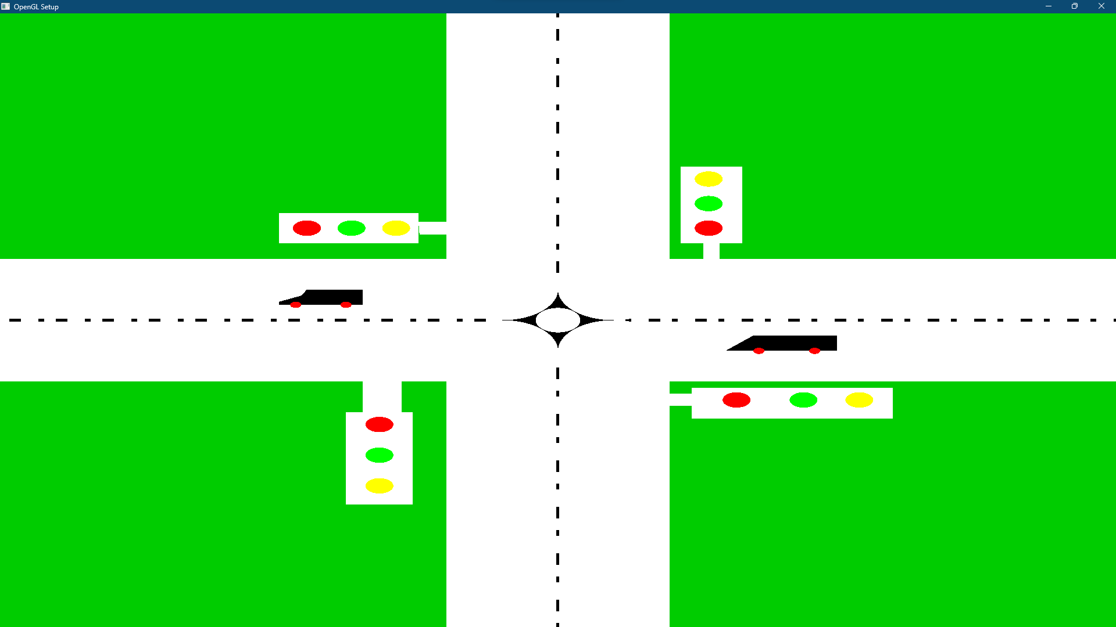

Question- 2

Draw two village scenarios for day and night using function to represent each object

Graph Plot (Picture)-
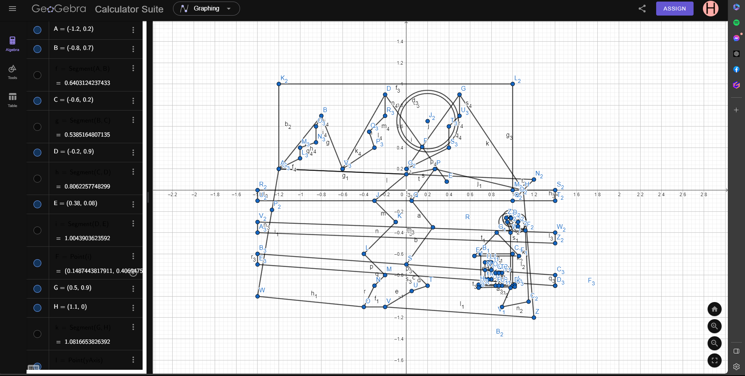

Code-
#include <windows.h>
#include <GL/glut.h>
#include<math.h>
#include<iostream>
using namespace std;
void Sky()
{
glBegin(GL_POLYGON);

glColor3f(0x6A / 255.0f, 0x6F / 255.0f, 0xAF / 255.0f);
glVertex2f(-1.2, 1);
glVertex2f(1, 1);

glColor3f(0xC8 / 255.0f, 0xC9 / 255.0f, 0xE5 / 255.0f);
glVertex2f(1.05, -0.05);
glVertex2f(-1.2, 0.2);

glEnd();

glFlush();
}
void rivr()
{
glBegin(GL_POLYGON);

glColor3f(1.0f, 1.0f, 1.0f);
glVertex2f(0, 0.2);
glVertex2f(-0.3, -0.1);
glVertex2f(-0.1, -0.3);
glVertex2f(-0.4, -0.6);
glVertex2f(-0.2, -0.8);
glVertex2f(-0.3, -0.9);
glVertex2f(-0.4, -1.1);
glVertex2f(-0.2, -1.1);
glVertex2f(0.05, -0.95);
glVertex2f(0.2, -0.9);
glVertex2f(0, -0.7);
glVertex2f(0.25, -0.35);
glVertex2f(0.05, -0.1);
glVertex2f(0.2680683815806, 0.1990663142448);
glVertex2f(0, 0.2);

glEnd();

//tree circle

glFlush();
}

void hous()
{
//body
glBegin(GL_POLYGON);

glColor3f(0x99 / 255.0f, 0x69 / 255.0f, 0x43 / 255.0f);

glVertex2f(0.7, -0.6);
glVertex2f(0.7, -0.9);
glVertex2f(1, -0.9);
glVertex2f(1, -0.6);

glEnd();
//head
glBegin(GL_POLYGON);

glColor3f(0xDB / 255.0f, 0xC0 / 255.0f, 0x8B / 255.0f);

glVertex2f(0.64, -0.62);
glVertex2f(1.06, -0.62);
glVertex2f(0.85, -0.4);

glEnd();
//window
glBegin(GL_POLYGON);

glColor3f(0xE5 / 255.0f, 0xF3 / 255.0f, 0xE4 / 255.0f);

glVertex2f(0.74, -0.68);
glVertex2f(0.74, -0.84);
glVertex2f(0.8, -0.84);
glVertex2f(0.8, -0.68);

glEnd();
//door
glBegin(GL_POLYGON);

glColor3f(0xE5 / 255.0f, 0xF3 / 255.0f, 0xE4 / 255.0f);

glVertex2f(0.84, -0.78);
glVertex2f(0.9, -0.78);
glVertex2f(0.9, -0.9);
glVertex2f(0.84, -0.9);

glEnd();

glBegin(GL_POLYGON);

glColor3f(0xE5 / 255.0f, 0xF3 / 255.0f, 0xE4 / 255.0f);

glVertex2f(0.68, -0.89);
glVertex2f(0.6800379059788, -0.9185509677358);
glVertex2f(1.02, -0.91);
glVertex2f(1.02, -0.89);

glEnd();

glFlush();

}
void mud()
{
glBegin(GL_POLYGON);

glColor3f(0.4f, 0.2f, 0.0f);
glVertex2f(-1.2, 0.2);

glColor3f(1.0f, 1.0f, 1.0f);
glVertex2f(1.2, 0.2);

glColor3f(0.6f, 0.4f, 0.2f);
glVertex2f(1.05, -0.05);

glEnd();
glFlush();
}
void tree()
{
//body
glBegin(GL_POLYGON);

glColor3f(0x62 / 255.0f, 0x4B / 255.0f, 0x21 / 255.0f);

glVertex2f(0.9, -1.1);
glVertex2f(1.15, -1.05);
glVertex2f(1.12, -0.38);
glVertex2f(0.95, -0.3);
glVertex2f(0.98, -0.4);

glVertex2f(1, -0.9);

glEnd();

glBegin(GL_POLYGON);
float xOffa = 0.95, f;
float yOffa = -0.3f;
for (int i = 0; i < 300; i++)
{

glColor3f(0x4B / 255.0f, 0x5C / 255.0f, 0x26 / 255.0f);

float pi = 3.1416;
float a = (i * 2 * pi) / 300;
float r = 0.08;
float x = r * cos(a) + xOffa;
float y = r * sin(a) + yOffa;
glVertex2f(x, y);

}

glEnd();

glBegin(GL_POLYGON);
float xOff = 0.985;
float yOff = -0.265f;
for (int i = 0; i < 300; i++)
{

glColor3f(0x4B / 255.0f, 0x5C / 255.0f, 0x26 / 255.0f);

float pi = 3.1416;
float a = (i * 2 * pi) / 300;
float r = 0.08;
float x = r * cos(a) + xOff;
float y = r * sin(a) + yOff;
glVertex2f(x, y);

}

glEnd();
glFlush();
}
void mountain()
{
glBegin(GL_POLYGON);

glColor3f(0.8f, 0.9f, 0.98f);
glVertex2f(-1.2, 0.2);
glColor3f(1.0f, 1.0f, 1.0f);
glVertex2f(-0.8, 0.7);
glVertex2f(-0.6, 0.2);

glEnd();

glBegin(GL_POLYGON);

glColor3f(0.8f, 0.9f, 0.98f);
glVertex2f(-0.6, 0.2);

glColor3f(1.0f, 1.0f, 1.0f);
glVertex2f(-0.2, 0.9);
glVertex2f(0.38, 0.08);

glEnd();

glBegin(GL_POLYGON);

glColor3f(0.8f, 0.9f, 0.98f);
glVertex2f(0, 0.2);

glColor3f(1.0f, 1.0f, 1.0f);
glVertex2f(0.5, 0.9);
glVertex2f(1.1, 0);

glEnd();

glBegin(GL_POLYGON);

glColor3f(0xD3 / 255.0f, 0xED / 255.0f, 0xEE / 255.0f);
glVertex2f(-1.2, 0.2);
glVertex2f(-1, 0.3);
glVertex2f(-1, 0.4);

glColor3f(0xC8 / 255.0f, 0xC9 / 255.0f, 0xE5 / 255.0f);
glVertex2f(-0.85, 0.45);
glVertex2f(-0.85, 0.6);
glVertex2f(-0.8, 0.7);

glEnd();

glBegin(GL_POLYGON);

glColor3f(0xD3 / 255.0f, 0xED / 255.0f, 0xEE / 255.0f);
glVertex2f(-0.6, 0.2);
glVertex2f(-0.2, 0.9);
glVertex2f(-0.2, 0.7);

glColor3f(0xC8 / 255.0f, 0xC9 / 255.0f, 0xE5 / 255.0f);
glVertex2f(-0.35, 0.55);
glVertex2f(-0.3, 0.4);
glVertex2f(-0.6, 0.2);
glEnd();

glBegin(GL_POLYGON);

glColor3f(0xD3 / 255.0f, 0xED / 255.0f, 0xEE / 255.0f);
glVertex2f(0, 0.2);
glVertex2f(0.5, 0.9);
glVertex2f(0.5, 0.7);

glColor3f(0xC8 / 255.0f, 0xC9 / 255.0f, 0xE5 / 255.0f);
glVertex2f(0.4, 0.6);
glVertex2f(0.4, 0.4);
glVertex2f(0, 0.2);
glEnd();
glFlush();
}

void sun()
{

glBegin(GL_POLYGON);
float xOff2 = 0.2;
float yOff2 = 0.65;

for (int i = 0; i < 300; i++) {
// Calculate the fade color from yellow to light white
float fadeFactor = static_cast<float>(i) / 300.0f;
glColor3f((255 - fadeFactor * (255 - 230)) / 255.0f,
(206 - fadeFactor * (206 - 230)) / 255.0f,
(7 - fadeFactor * (7 - 230)) / 255.0f);

float pi = 3.1416;
float a = (i * 2 * pi) / 300;
float r = 0.29;
float x = r * cos(a) + xOff2;
float y = r * sin(a) + yOff2;
glVertex2f(x, y);
}

glEnd();
glFlush();
}
void moonBorder() {
glBegin(GL_LINE_LOOP);
glColor3f(0.0f, 0.0f, 0.0f);

float xOff2 = 0.2;
float yOff2 = 0.65;
float radius = 0.29;

for (int i = 0; i < 300; i++) {
float pi = 3.1416;
float a = (i * 2 * pi) / 300;
float x = radius * cos(a) + xOff2;
float y = radius * sin(a) + yOff2;
glVertex2f(x, y);
}

glEnd();
}
void moon()
{
glBegin(GL_POLYGON);
float xOff2 = 0.2;
float yOff2 = 0.65;

for (int i = 0; i < 300; i++) {

float fadeFactor = static_cast<float>(i) / 300.0f;
glColor3f((0 + fadeFactor * (255 - 0)) / 255.0f,
(0 + fadeFactor * (255 - 0)) / 255.0f,
(0 + fadeFactor * (255 - 0)) / 255.0f);

float pi = 3.1416;
float a = (i * 2 * pi) / 300;
float r = 0.29;
float x = r * cos(a) + xOff2;
float y = r * sin(a) + yOff2;
glVertex2f(x, y);
}

glEnd();

glColor3f(1.0f, 1.0f, 1.0f);
glPointSize(2.0f);
glBegin(GL_POINTS);

for (int i = 0; i < 20; i++) {
float xStar = static_cast<float>(rand()) / static_cast<float>(RAND_MAX) * 2.2 - 1.2;
float yStar = static_cast<float>(rand()) / static_cast<float>(RAND_MAX) * 1.2 - 0.05;

glVertex2f(xStar, yStar);
}

glEnd();
glFlush();
}

void ground()
{
glBegin(GL_POLYGON);

glColor3f(121 / 255.0f, 173 / 255.0f, 98 / 255.0f);

glVertex2f(-1.4, 0);
glVertex2f(-1.4, -0.1);
glVertex2f(1.4, -0.1);
glVertex2f(1.4, 0);

glEnd();

glBegin(GL_POLYGON);

glColor3f(121 / 255.0f, 173 / 255.0f, 98 / 255.0f);

glVertex2f(-1.4, -0.3);
glVertex2f(-1.4, -0.4);
glVertex2f(1.4, -0.5);
glVertex2f(1.4, -0.4);

glEnd();

glBegin(GL_POLYGON);

glColor3f(121 / 255.0f, 173 / 255.0f, 98 / 255.0f);

glVertex2f(-1.4, -0.6);
glVertex2f(-1.4, -0.7);
glVertex2f(1.4, -0.9);
glVertex2f(1.4, -0.8);

glEnd();
glFlush();
}

void nightsky()
{
glBegin(GL_POLYGON);

glColor3f(0.0f, 0.0f, 0.0f);
glVertex2f(-1.2, 1);

glColor3f(0.5f, 0.5f, 0.5f);
glVertex2f(1, 1);

glColor3f(1.0f, 1.0f, 1.0f);
glVertex2f(1.05, -0.05);

glColor3f(0.5f, 0.5f, 0.5f);
glVertex2f(-1.2, 0.2);

glEnd();

glColor3f(1.0f, 1.0f, 1.0f);
glPointSize(2.0f);
glBegin(GL_POINTS);

for (int i = 0; i < 100; i++) {
float x = static_cast<float>(rand()) / static_cast<float>(RAND_MAX) * 2.2 - 1.2;
float y = static_cast<float>(rand()) / static_cast<float>(RAND_MAX) * 1.2 - 0.05;

glVertex2f(x, y);
}

glEnd();

glFlush();
}

int currentScene = 1;

//Press 1 For Day Press 2 For Night
void display() {
glClearColor(0.0f, 0.8f, 0.0f, 1.0f);
glClear(GL_COLOR_BUFFER_BIT);

if (currentScene == 1) {
Sky();
sun();
mountain();
ground();
mud();
rivr();
tree();
hous();
}
else if (currentScene == 2) {
nightsky();
moon();
moonBorder();
mountain();
ground();
mud();
rivr();
tree();
hous();
}

glutSwapBuffers();
}

void key_callback(unsigned char key, int x, int y) {
if (key == '1' || key == '2') {
currentScene = key - '0';
glutPostRedisplay();
}
}

int main(int argc, char** argv) {
glutInit(&argc, argv);
glutCreateWindow("Press 1 For Day Press 2 For Night");
glutInitWindowSize(800, 600);
glutDisplayFunc(display);
glutKeyboardFunc(key_callback);

glutMainLoop();

return 0;
}

Output Screenshot (Full Screen)-
